# JavaCodeStep

**Objective:**

It is used to execute any Custom external java code.

**Attributes:**

|  |  |
| --- | --- |
| **Attributes** | **Description** |
| class_name | To enter name of the class |
| package_name | To enter name of the package |

**Sample config.json:**

{

"workflows": [

{

"name": "code-java",

"id": 200,

"trigger": "rest",

"expression": "code-java",

"method": "GET",

"steps": [

{

"type": "start",

"id": 1,

"next": {

"start": "start"

}

},

{

"class_name": "AppupServerImpl",

"package_name": "com.javacode.exe",

"type": "code-java",

"id": "start",

"next": {

"success": "code-java-success",

"failure": "hangup"

}

},

{

"variable_name": "numbervalue",

"http_response_code": "200",

"response_content_type": "text/html",

"value_type": "hb",

"type": "send",

"id": "code-java-success",

"next": {

"success": "hangup",

"failure": "hangup"

}

}

]

}

],

"filters": [],

"server": {},

"plugins": []

}

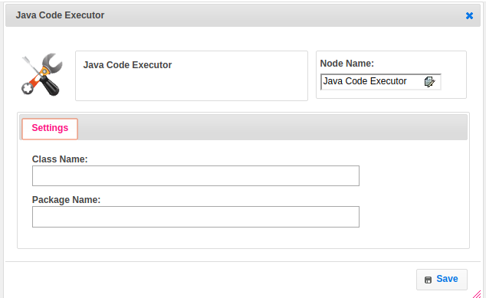

**Executor Description:**

In executor class first it Load the respective class given in step from Application Library class path. Creates a new instance for given class and executes that class then stored into map and returns the status as success.